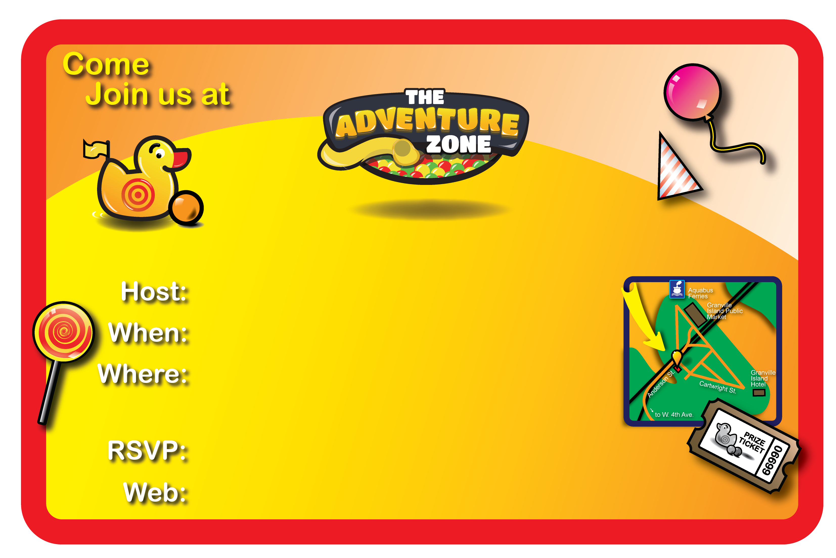
Enter your Name Here
for Dana’s 0th Birthday!!
Enter Your Birthday Party Date, & Time
The Adventure Zone,
2nd Floor, Kids Market, Granville Island,
1496 Cartwright St., Vancouver BC, V6H 3Y5
Enter your e-mail, and phone number
www.theadventurezone.ca
• Please remember that socks are required in the playground area.
• You are welcome to bring your own food & beverages. But please, no alcohol.

